Name: Noor Aweys Hassan

Assignment: Python Project Setup, Git, and GitHub Workflow

Part A - Project Setup Using the CLI

The screenshoot
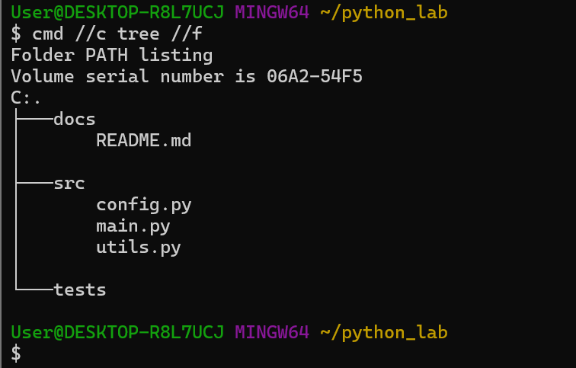

Command Descriptions.
· mkdir ~/python_lab: Creates a new directory named python_lab inside your Windows user home folder (C:\Users\User).
· cd ~/python_lab: Moves your terminal's current working location into the new python_lab directory.
· mkdir src tests docs: Generates three subdirectories (src, tests, and docs) inside the project folder at the same time.
· touch src/main.py src/utils.py src/config.py: Creates three blank Python files inside the src folder using Git Bash's built-in Unix utilities.
· echo "My Python Lab Project" > docs/README.md: Uses standard output redirection (>) to write the specified string into a new README.md file without opening an editor.
· tree .: Fails with a command not found error because the standard Linux tree utility is not pre-installed in Git Bash on Windows.
· find . -not -path '*/.*': Fails with a syntax error because Git Bash on Windows parses quotes and wildcard patterns differently than native Linux.
· cmd //c tree //f: Calls the native Windows command prompt to successfully print the recursive visual structure of all folders and files.

The Importance of Separating Code Structures
Separating a project into logical directories like src, tests, and docs is an essential software engineering best practice that yields significant benefits even for small projects. First, it enforces a clean separation of concerns; keeping raw application logic hidden inside src prevents it from being cluttered by infrastructure metadata, user documentation, or testing scripts. Second, this structured arrangement drastically improves maintainability and scalability. As a project expands, developers know precisely where to deploy new functional elements, update user instructions, or introduce code validation scripts without breaking the codebase. Lastly, this standardized footprint ensures seamless integration with modern automation tooling—such as test runners (pytest), document generators (Sphinx), or CI/CD pipelines—which inherently look for files grouped in these predictable, conventional folder paths

Part B - Git Initialization and First Commit

The screenshoot of B
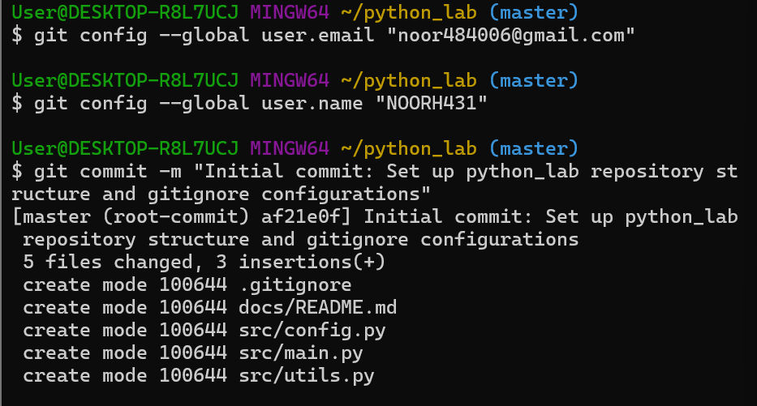

What .gitignore Does and Why the Patterns Matter
· A .gitignore file is a configuration text file that tells Git which specific files or directories to permanently ignore and exclude from version control tracking.
· The explicit exclusions matter for the following reasons:
- __pycache__/ and *.pyc: These are compiled Python bytecode objects generated dynamically by the interpreter when scripts run. They change constantly, clutter your version history unnecessarily, and can cause cross-platform execution conflicts if shared with other developer systems.
· .env: These files house sensitive application keys, database passwords, and environment credentials. Excluding them prevents you from accidentally leaking secure secrets onto public cloud environments like GitHub.

What information the commit history reveals about a project's development over time
The repository commit history behaves as a secure, linear ledger tracking the lifetime timeline of software development. It surfaces critical contextual details including who injected updates (author identity), when modifications landed (cryptographic timestamps), and why code architectural shifts took place (through explicit commit messages). Over an extended period, it exposes macro engineering patterns—revealing code stabilization velocities, showing how bugs roll back smoothly, and documenting feature progression across separate development branches.

Part C - Writing and Committing Python Code

When main.py executes the line from utils import ..., Python's import system resolves the dependency by searching through a pre-defined sequence of locations stored in sys.path. In this workspace setup, appending the absolute path of the current file's directory tells Python precisely where to look. Once the interpreter locates utils.py inside that folder, it compiles the code module into memory. This maps the specific function definitions (square, is_even, and celsius_to_fahrenheit) directly into the global execution namespace of main.py, allowing them to be called securely as local processes.

Enter a number to process: 4

--- Results for 4.0 ---
Square: 16.0
Is Even/Odd: Even
Fahrenheit equivalent: 39.2°F

Enter a number to process: 7

--- Results for 7.0 ---
Square: 49.0
Is Even/Odd: Odd
Fahrenheit equivalent: 44.6°F

Enter a number to process: 0

--- Results for 0.0 ---
Square: 0.0
Is Even/Odd: Even
Fahrenheit equivalent: 32.0°F

Part D - Publishing to GitHub and Branch Workflow
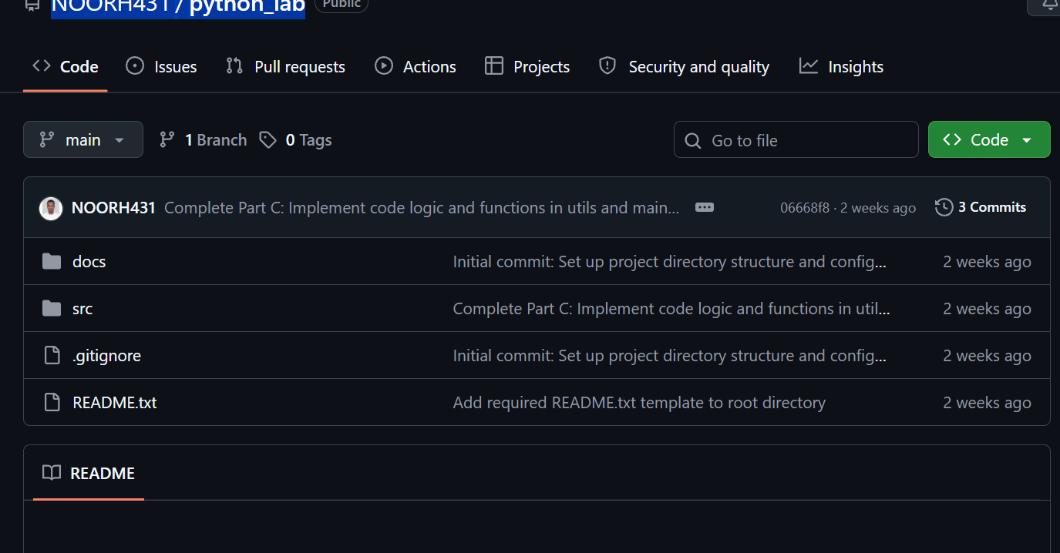
The link
NOORH431/python_lab

